D.Y. PATIL PRATISHTHAN’S COLLEGE OF ENGINEERING,

# SALOKHENAGAR, KOLHAPUR

### DEPARTMENT OF COMPUTER SCIENCE AND ENGINEERING (DATA SCIENCE)

**(2021-22)**



**A Mini Project**

**Report**

**on**

“BLOG USING FLASK-PYTHON”

# Submitted by:

**NAME- ROLL No.-**

**Mr. Pruthviraj Rajendra Chavan 08**

**Mr. Prathamesh Prakash Mandavkar 31**

**Mr. Dhruv Sanjay Sambrekar 52**

**Mr. Shreyas Shridhar Phansalkar 45**

**Mr. Ganesh Hanmant Pawar 43**

**Under the guidance of Prof. Mr.**

### DEPARTMENT OF COMPUTER SCIENCE AND ENGINEERING (DATA SCIENCE)

**Year of Submission: 2021-22**

D.Y. PATIL PRATISHTHAN’S COLLEGE OF ENGINEERING,

# SALOKHENAGAR, KOLHAPUR



CERTIFICATE

This is to certify that the following members have satisfactorily completed the Mini Project work entitled **“**BLOG USING FLASK-PYTHON**”** at SY (DS) semester-IV as prescribed in the syllabus of “Shivaji University, Kolhapur” during the academic year 2021-2022.

**NAME- PRN No.-**

Mr. Pruthviraj Rajendra Chavan 2020082678

Mr. Prathamesh Prakash Mandavkar 2020082544

Mr. Dhruv Sanjay Sambrekar 2020082547

Mr. Shreyas Shridhar Phansalkar 2020082942

Mr. Ganesh Hanmant Pawar 2020082557

**----------------- Prof. Ganesh. I. Rathod**

(Project Guide) **(**HOD)

**Prof. Dr. S.D.Mane External Examiner**

(Principal)

**ACKNOWLEDGEMENT**

We express our sincere thanks to **Prof. Mr Shrikant Bhople** whose guidance proved to be the most valuable to overcome all the hurdles in the fulfillment of this project.

We are deeply indebted to our Head of Department **Prof.G. I. Rathod**, Principal **Dr.S.D.Mane** and the college for providing us with a platform to excel in life.

We feel gratified to record our cordial thanks to other staff members of the C.S.E(Data Science) Department for their support, help and assistance which they extend as and when required.

**Date:**

**Place:** Kolhapur

### Name of Student Sign

Mr. Pruthviraj Rajendra Chavan

Mr. Prathamesh Prakash Mandavkar

Mr. Dhruv Sanjay Sambrekar

Mr. Shreyas Shridhar Phansalkar

Mr. Ganesh Hanmant Pawar

**INDEX**

|  |  |  |
| --- | --- | --- |
| Sr. No. | Title | Page No. |
|  | Acknowledgement | I |
|  | Contents | II |
|  | Abstract | III |
| 1. | Introduction | 7 |
| 2. | Problem Statement | 8 |
| 3. | Literature review | 9 |
| 4. | Outline of the system | 10 |
| 5. | Developement   * 1. Methodology   2. System requirements   3. Data flow diagram   4. project flow diagram | 12 |
| 6. | Results | 16 |
| 7 | Conclusion and future work | 21 |
| 8 | Reference | 22 |

**DECLARATION BY STUDENT**

I hereby declare that the Project work entitled **Blog Website using Flask Python** completed and written by me has not previously formed the basis for the award of any Degree or Diploma or other similar title of this or any other University or examining body.

**Date:**

**Place:**

**NAME**

Mr. Pruthviraj Rajendra Chavan

Mr. Prathamesh Prakash Mandavkar

Mr. Dhruv Sanjay Sambrekar

Mr. Shreyas Shridhar Phansalkar

Mr. Ganesh Hanmant Pawar

**Abstract**

A blog or weblog is an online platform publishing so-called blog content. A blog may be the work of a single person or jointly operated by a group of people, and bloggers tend to use [content management systems](https://www.textbroker.com/content-management-system) or blog software such as WordPress, Blogger, or Joomla. The blog environment is known as the blogosphere.

Although blogging might seem like the work of an author or writer, you could actually explore it as long as you know where you are good at and what you want to talk about. If you’re a professional programmer and want to explore blogging this time, get that opportunity and start your blog. A few more tools, time, and commitment to help you with the writing process is all you need to establish a blog that will rock the programming world.

We created blog project using flask in python, when we start to create this project we learned about frontend technology like HTML-CSS, jinja, bootstrap and for backend technology like flask, flask_wtf, functools, werkzeug, flask_sqlalchemy, wtforms, flask_ckeditor, flash_login, flask_gravatar & smtplib. For database we used SQLite-database.

**1.Introduction**

A **blog** is a type of **website** that is updated regularly with new content. Most blogs contain short, informal articles called **blog posts**. These posts usually contain some combination of **text**, **photos**, **videos**, and other media. At its core, a blog is just a space on the Web that you can create to record and express your **opinions**, **experiences**, and **interests**.

If you spend much time browsing the Web, you've probably read a blog post before, even if you didn't realize it at the time. Some of the most-read blogs are a bit like online magazines because they're written by a team of people who are paid to update the blog with new posts several times a day.

**State of Art**

Overview

We created blog project using flask in python, when we start to create this project we learned about frontend technology like HTML-CSS, jinja, bootstrap and for backend technology like flask, flask_wtf, functools, werkzeug, flask_sqlalchemy, wtforms, flask_ckeditor, flash_login, flask_gravatar & smtplib. For database we used SQLite-database.

**2 Problem Statement**

As you saw in the infographic on the last page, most bloggers consider blogging a **hobby**. It can be a fairly time-consuming hobby, as many bloggers spend several hours each week writing blog posts, replying to comments, and more. So why do they do it?

There are many reasons why people blog, but here are some of the most common reasons:

* To share your experiences and expertise
* To speak up about an issue you care about
* To become more involved with hobbies and passions
* To be part of a community
* To advance your career or start a career in writing
* To keep family and friends updated about your life

No matter what their **main reason** for blogging is, most bloggers have at least one thing in common: They're **passionate** enough about a topic to **write** about it over and over again, usually for free. If there's a subject you care deeply about, you might enjoy blogging about it. When you have your own blog, you have **unlimited space and freedom** to **express your opinions** and discuss the things you care about with others.

The Benefits of Blogging for Business

* It helps drive traffic to your website. ...
* You can repurpose blog content for social media. ...
* It helps convert traffic into leads. ...
* It drives long-term results. ...
* Blogging helps with link building. ...
* It drives long-term results. ...
* It helps you share company news.

**3 Literature Review**

# Why Every Programmer Should Start Their Own Blog ?

Every blogger knows their motivation, purpose, and the exact reasons why they started a blog beforehand. Some just wanted a space to vent and share their stories or ideas. Some are desperate to help people through the information on their blog, while some want to make blogging their career. Every reason is valid, and you can’t argue that blogging can lead you to positive propositions, such as the following:

**1. Extend Your Knowledge About Programming**

Programming is a broad field that you can use to establish your blog. It has many topics and issues that you can cover to discuss and showcase on every blog post.

Writing is an effective way to broaden your knowledge about something, and as a programmer, you can expand your schema into something wider just by exploring new topics about programming.

Learning is a continuous and systematic process. So it would be a practical move to start your blog about programming fundamentals with issues, challenges, solutions, reviews, and tutorials. By covering these, you’ll unconsciously update your knowledge bank about programming, which could be to your advantage.

**2. Land Better and More Opportunities**

Blogging has been a real factor when it comes to landing new opportunities. For example, when you have plans to impress a client or a company, you can easily direct them to your site.

Once they see how articulate, knowledgeable, and passionate you are about programming, they won’t hesitate to trust or hire you. Likewise, if you have created your site and made it available online; your blog would be visible to many people.

You can leave your contact information, skill sets, qualifications, and previous projects on your blog so that interested people can reach you if they want your service.

**3. Grow Your Network**

Growing your network isn’t easy, especially if you’re not familiar with influencer marketing. If you’re having a hard time building your network as a programmer, blogging can give it to you. All you need to do is publish compelling programming content that would attract ordinary readers and programmers like you.

Ask them to share it to different social media platforms so you can increase brand awareness and earn engagements. Then, once you have the right content and a few more readers, you can eventually grow your network. Just keep publishing and posting.

**4. Improve Your Communication Skills**

Excellent communication skills are essential if you’re a programmer, especially if you need to impress a client. You will need it most when sealing a deal or negotiating about your project.

Then, how can blogging help you with it? Blogging is an expressive way to tell stories and relay information through writing. So, when you are writing, you will organize your thoughts and present them more comprehensively to your readers.

In this way, you are unconsciously improving your communication skills, both written and oral. Soon, in your career, you can use this skill to communicate better to your prospective clients and seal a successful deal right after. So it is not always your programming skills that matter. Sometimes it is also your communication skills.

# 5. An Organized Place for a Portfolio

Your previous projects are surely the pride of your programming skills, and they deserve to be in the spotlight. Aside from the written blog posts on your site, you could also use it as a safe place to showcase the portfolio of your previous projects.

You can display the links to your developed applications or software. Just make sure to get permission from your previous client before you do it, especially if they already own the application.A well-showcased portfolio can also give you more opportunities once interested parties see it. Finally, note that your portfolio will reflect your skills and potential in programming.

1. **Outline of the system**

4.1.1 Components of the System

The system is classified mainly into three sections or components, which are as follows –

* **Login page:**login in website using email.
* **Register page:** user can register by giving name, email, and creating password. You may use this feature to add, remove, or edit item details. You may enter information or data such as item number, item name, production date, price, quantity, tax percent, and more in the add items section.
* **Contact us page:** user can contact us.
* **About page:** In this page having information about us.
* **Home page:** In this page having all the posted blog post.
* **Edit post page:** In this page admin can edit the blog post.
* **Create post page:** In this page admin can create new blog post.
* **Delete post page:** Admin can delete the blog post.
* **Logout page:** Admin or User can logout from blog.

**4.1.2 Proposed System Block Diagram**

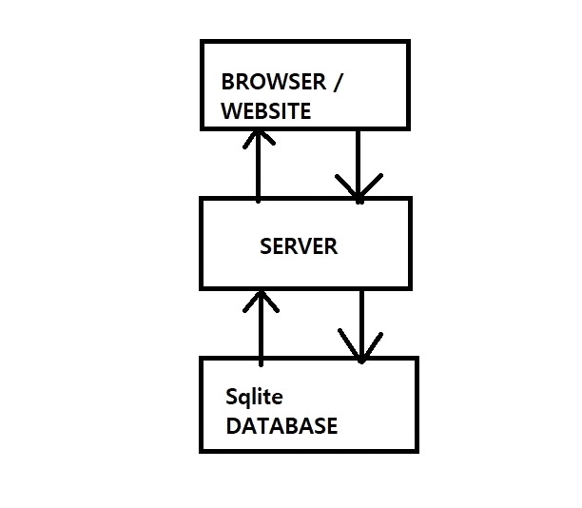

**Fig 4.1:** System Block Diagram

**5. Development**

5.1 Methodology

* We collected the Information About the given micro-project topic.
* We distributed the given work related to the micro-project to all the team members.
* We discussed about flow of the program in considering the algorithm as were as the flowchart.
* We executed program in a Visual Studio Code software properly.
* We have successfully run the program using the PYTHON.
* We had printout the print of the micro-project.
* We submitted the project to concerned teacher by taking signature on the report of the Micro-project.

5.2 System Requirements

5.2.1 Software Requirement details

Operating System : Windows 7

Front-end : HTML Bootstrap, jinja

Back-end : Flask-Python

Database : SQLite

Languages Used : Python

5.2.2 Hardware requirement details

Processor : Intel Core i3 Processor

RAM : 4GB (Minimum)

HDD : 40GB (Minimum)

5.3 Data Flow Diagram

Also known as DFD, Data flow diagrams are used to graphically represent the flow of data in a business information system. DFD describes the processes that are involved in a system to transfer data from the input to the file storage and reports generation. Data flow diagrams can be divided into logical and physical. The logical data flow diagram describes, flow of data through a system to perform certain functionality of a business. The physical data flow diagram describes the implementation of the logical data flow.

* Data Flow Diagram
* User Dataflow Diagram

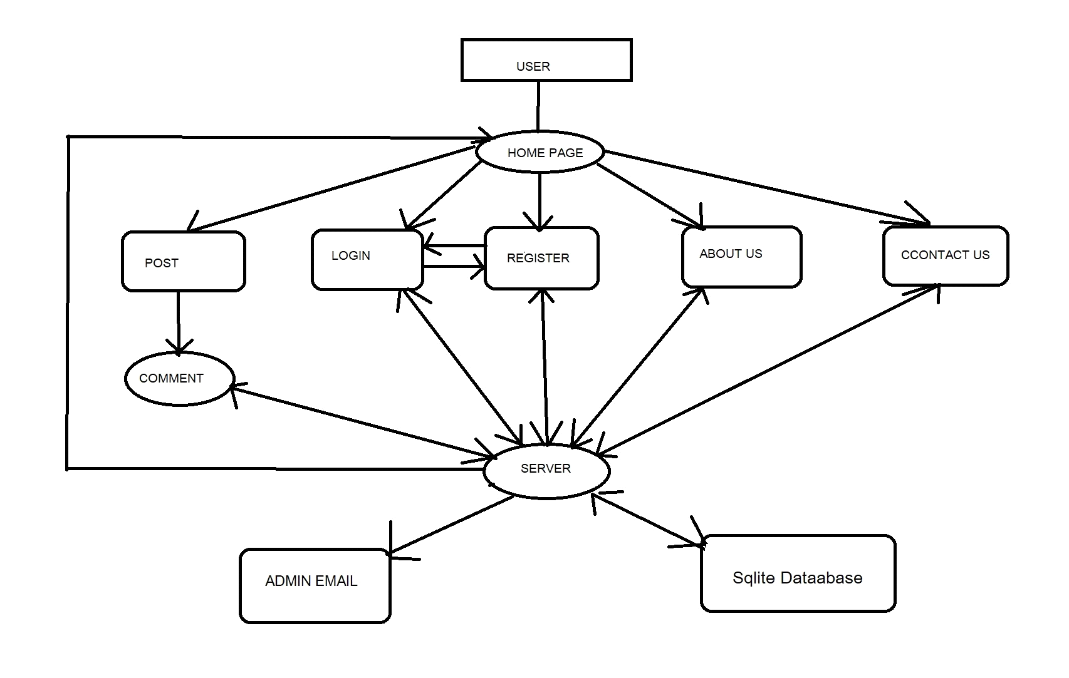

**Fig 5.1:** User Dataflow Diagram

* Data Flow Diagram
* Admin Dataflow Diagram

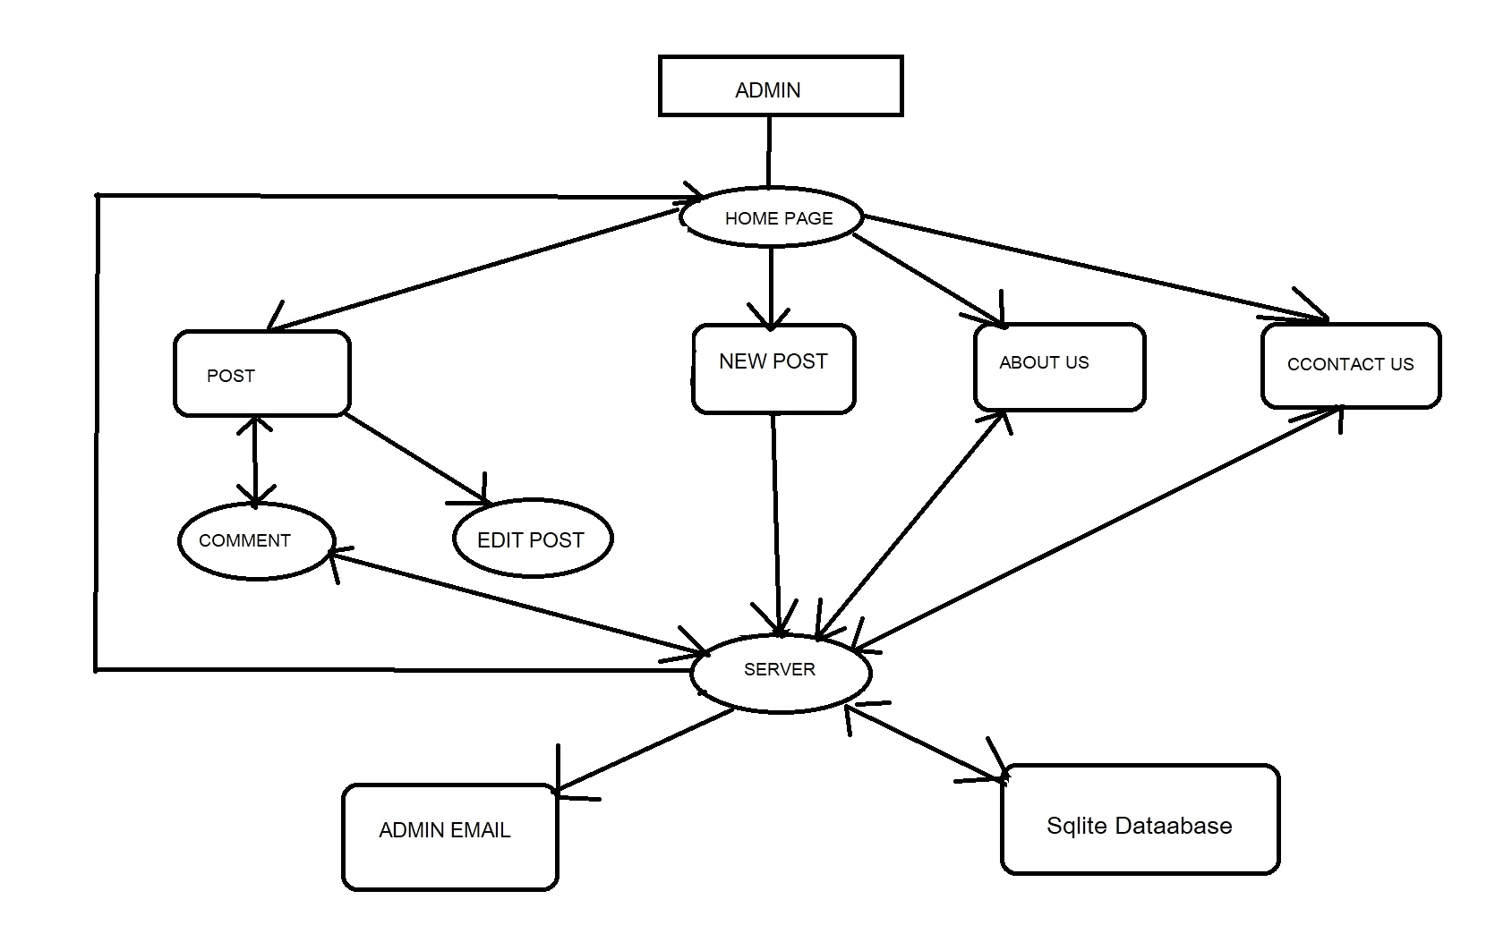

**Fig 5.2:** Admin Dataflow Diagram

**5.5 Project flow Diagram**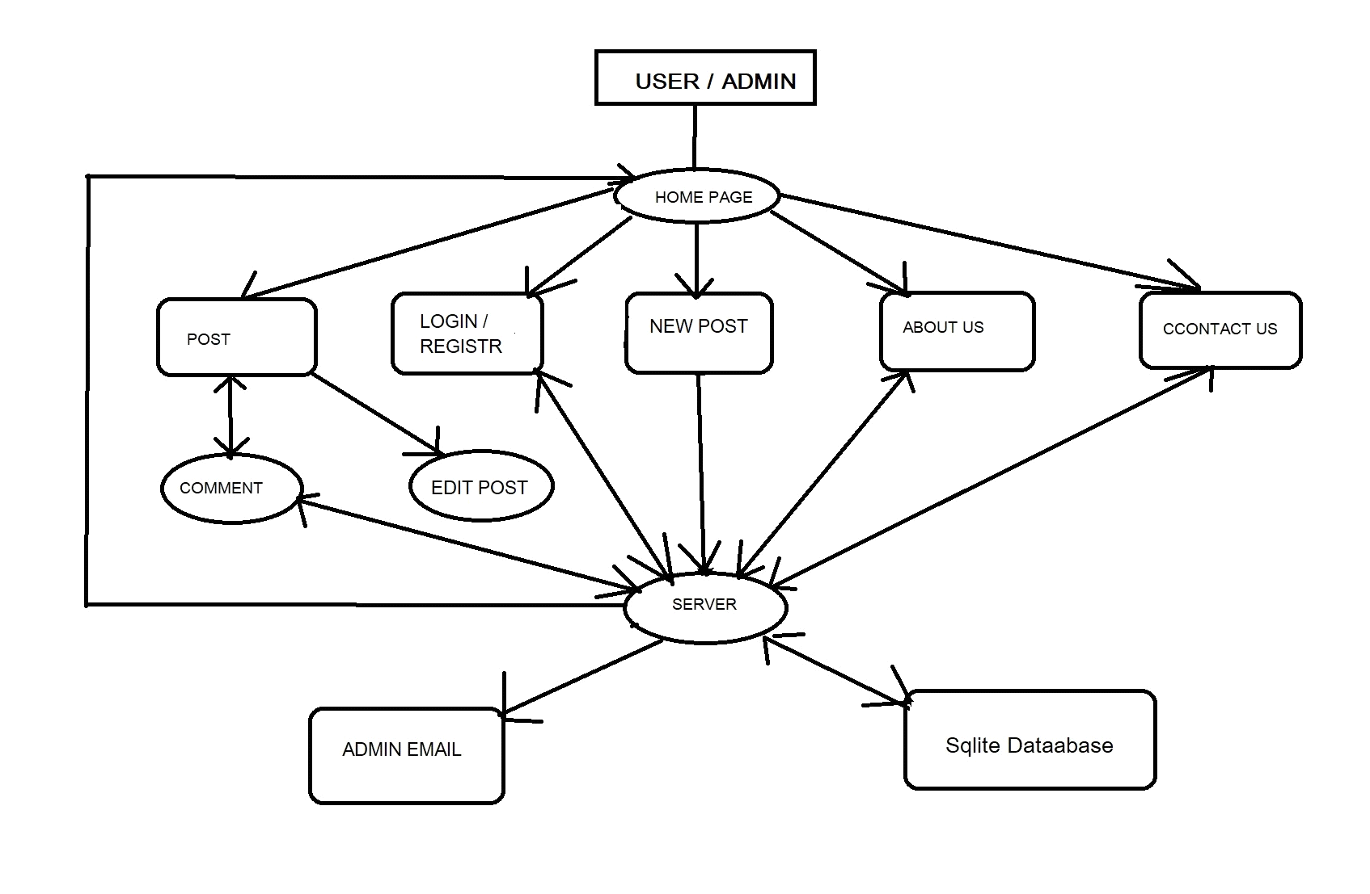

**Fig 5.3:** Project flow Diagram

6.1 User of Blog

6.1.1 Home page-

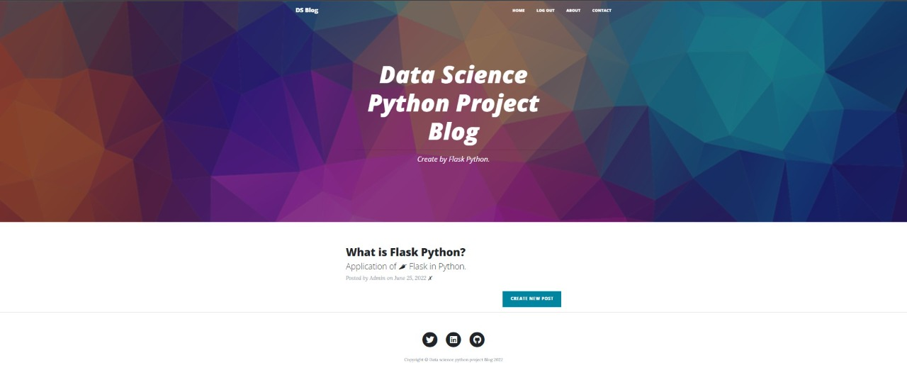

**6. RESULTS**

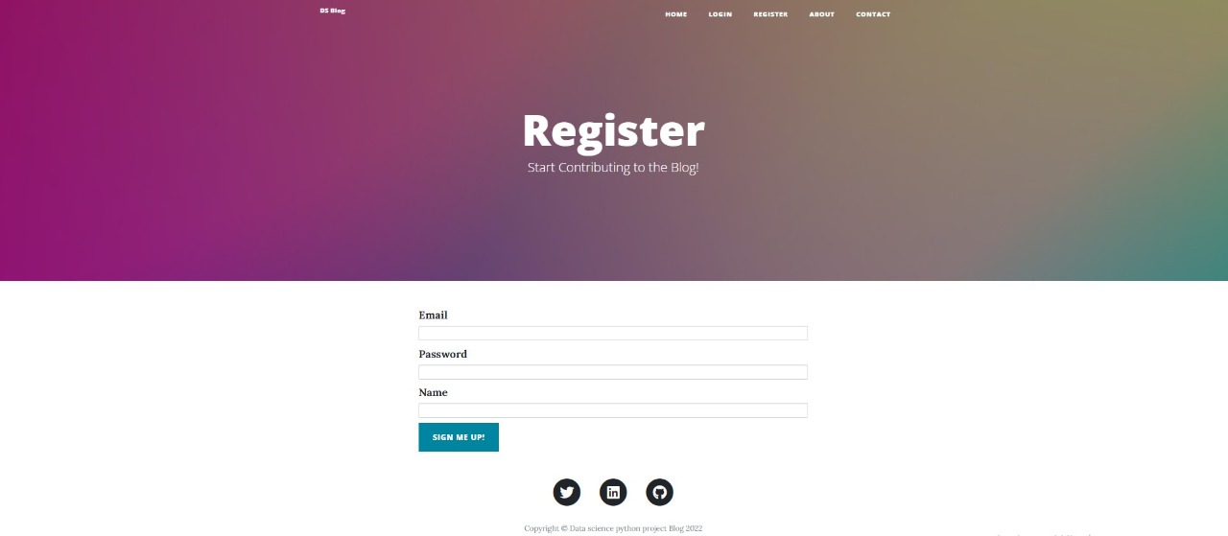

6.1.2 Register page-

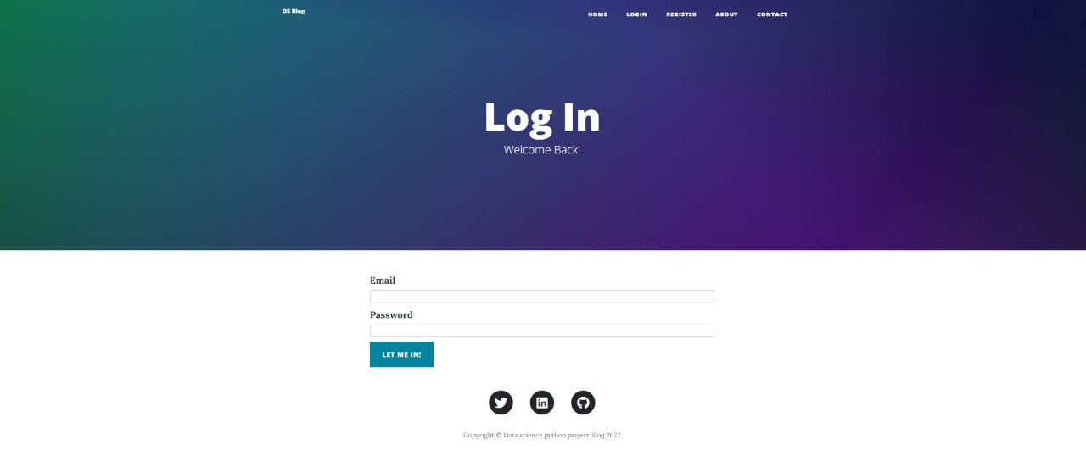

6.1.3 Login page-

6.1.4 Post page-

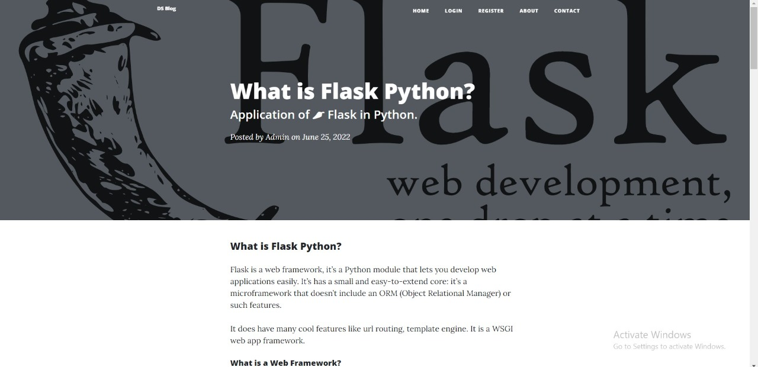

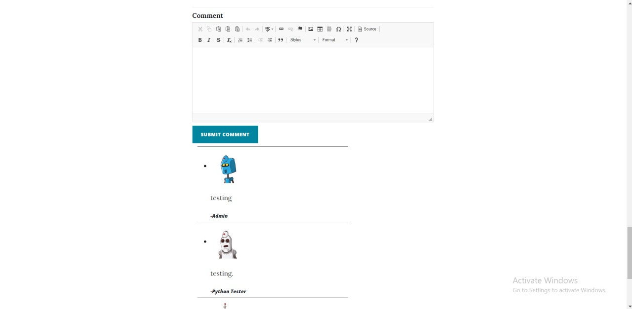

6.1.5 Comment box (post page)-



6.2 Admin of blog

6.2.1 Admin-login (Homepage)

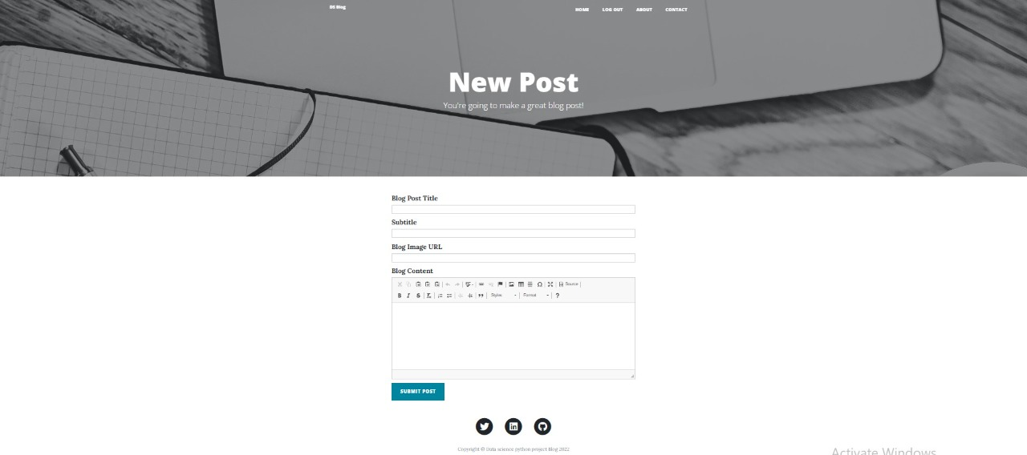

6.2.2 Admin-login (new post)

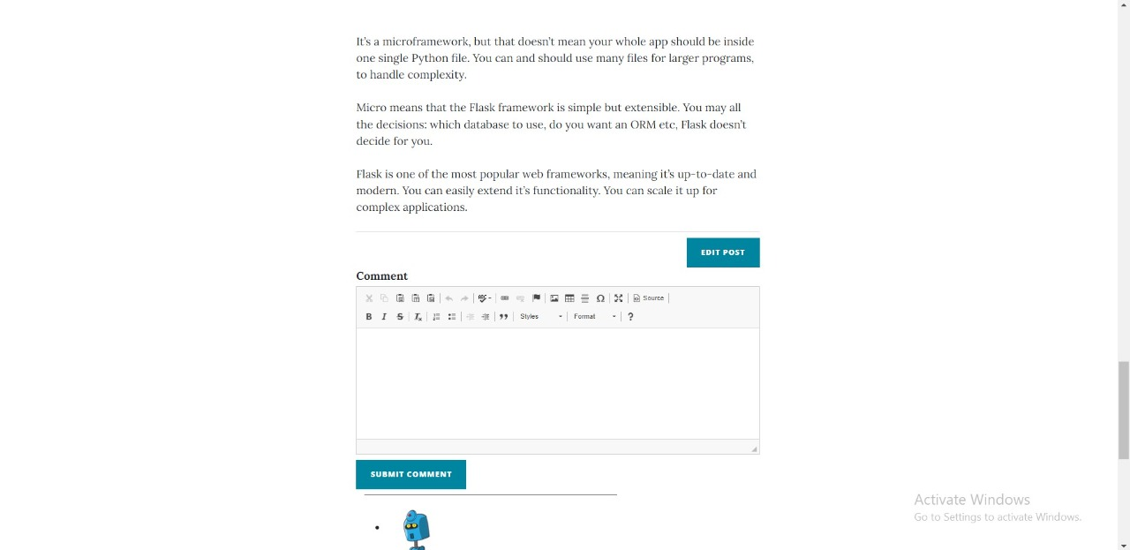

6.2.3 Edit blog post (admin login)

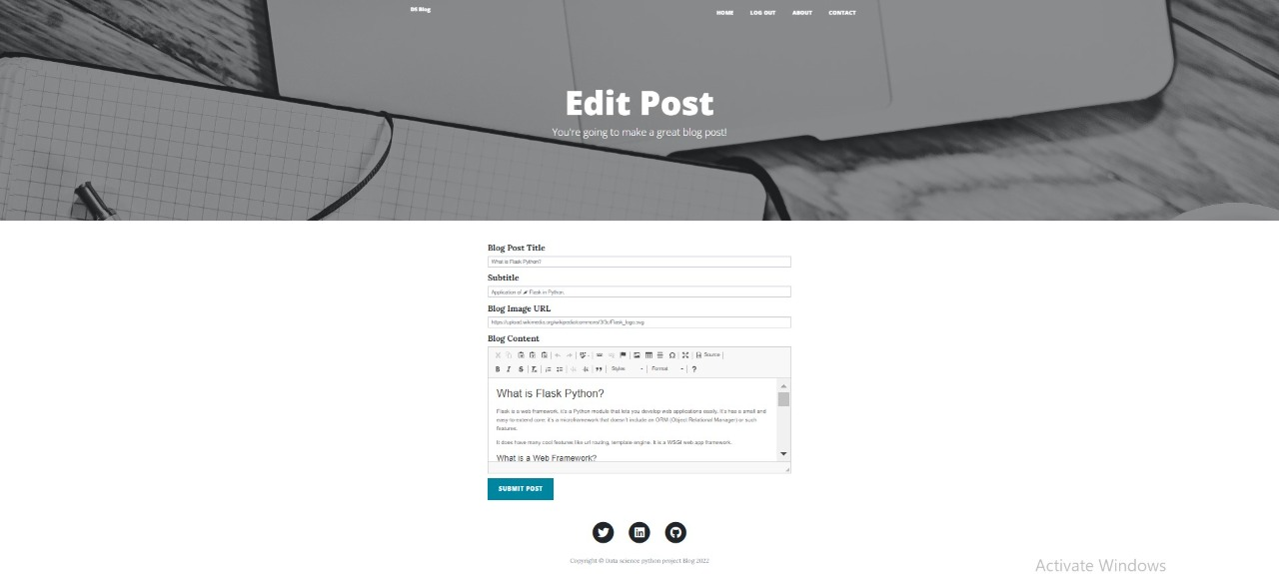

6.2.4 Editing blog post (admin login)

**7. Conclusion and Future Works**

7.1 Conclusion

We created blog project using flask in python , when we start to create this project we learned about frontend technology like HTML-CSS, jinja, bootstrap. and For backend technology like flask, flask_wtf, functools, werkzeug,flask_sqlalchemy, wtforms, flask_ckeditor, flash_login, flask_gravatar & smtplib . for database we used SQLite-database.

Although blogging might seem like the work of an author or writer, you could actually explore it as long as you know where you are good at and what you want to talk about. If you’re a professional programmer and want to explore blogging this time, get that opportunity and start your blog. A few more tools, time, and commitment to help you with the writing process is all you need to establish a blog that will rock the programming world.

7.2 Future Work

The Social Networking Site have wide range to change as per time requirement. That the reason behind that not a particular project is ever considered as complete, because what the demand of user and thinking always change day by day. Always do more than what have. Some of the enhance which we have thought of are:

We will show advertisement on blog.

We will give access to user to create and edit the post.

We will give access to user for delete and edit their comments.

We will make a page for user profile.

We will create password forgot page.

**8. Bibliography**

8.1 Document Reference

FLASK DOCUMENTATON:-

[**https://flask.palletsprojects.com/**](https://flask.palletsprojects.com/)

JINJA DOCUMENTATION:-

[**https://jinja.palletsprojects.com/**](https://jinja.palletsprojects.com/)

[BETTER PROGRAMMING:-](https://betterprogramming.pub/?source=post_page-----e494fcc3dbf5--------------------------------)

[**https://betterprogramming.pub/why-every-programmer-should-start-their-own-blog-e494fcc3dbf5**](https://betterprogramming.pub/why-every-programmer-should-start-their-own-blog-e494fcc3dbf5)